**OBIEE 12c Installation Procedure on Linux**

**Document Control**

**Change Records**

| Date | Author | Version | Change Reference |
| --- | --- | --- | --- |
|  |  |  |  |
| 08/08/2017 | VG DBA | 1.0 | Initial Document |
|  |  |  |  |
|  |  |  |  |

**Reviewers**

| Name | Position |
| --- | --- |
|  |  |
|  |  |
|  |  |
|  |  |
|  |  |

**Distribution**

| Copy No. | Name | Location |
| --- | --- | --- |
|  |  |  |
|  | Library Master | Project Library |
|  |  | Project Manager |
|  |  |  |
|  |  |  |

**Note to Holders:**

If you receive an electronic copy of this document and print it out, please write your name on the equivalent of the cover page, for document control purposes.

If you receive a hard copy of this document, please write your name on the front cover, for document control purposes.

**Certification Matrix for OBIEE 12.2.1.2.0:**

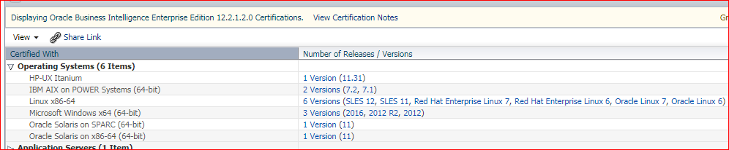

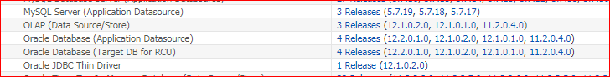

**Installation of 12c Database:**

Download the below softwares

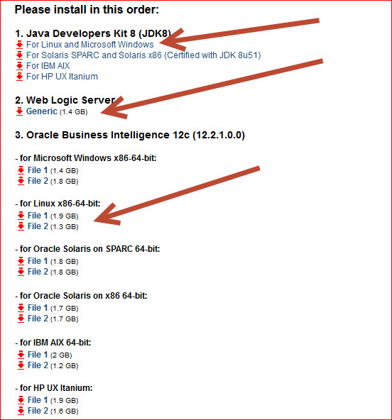

Create the users and group.

Complete all the prerequisites and start the installation of database

Unzip database software and run ./runInstaller

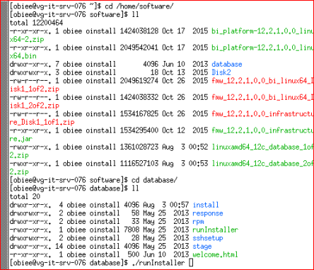

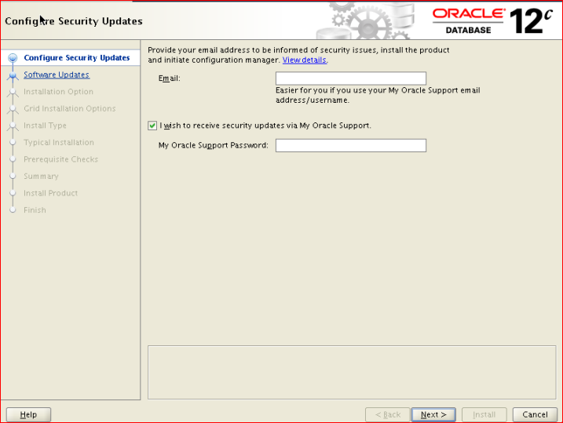

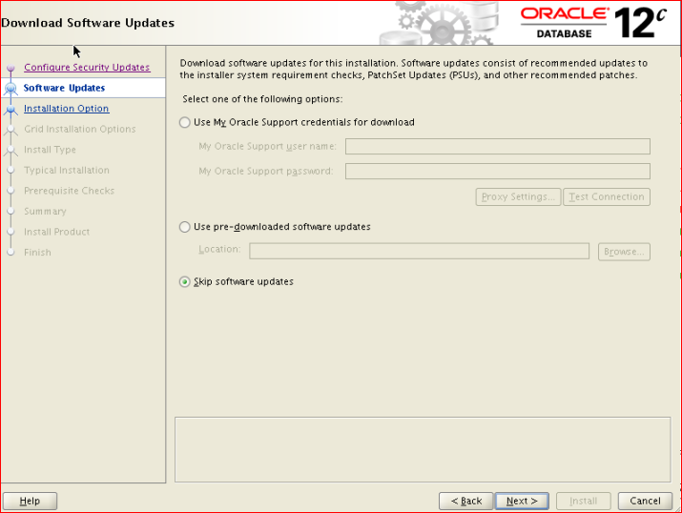

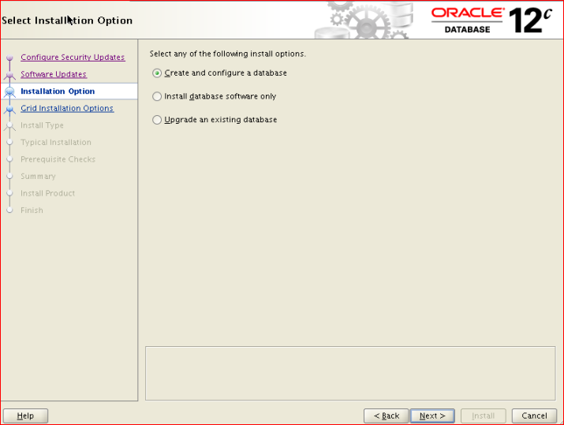

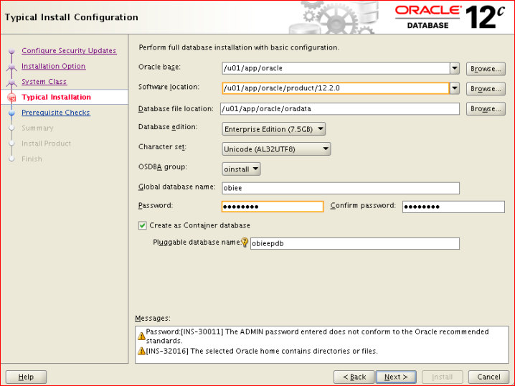

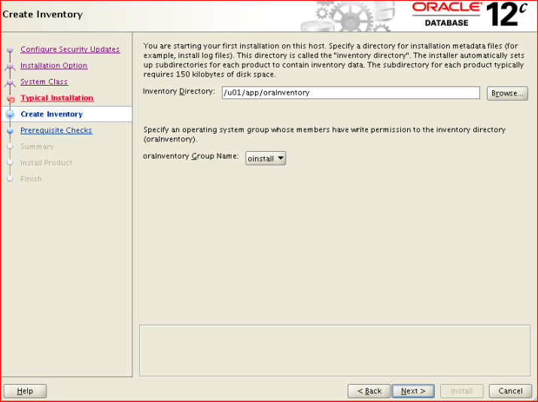

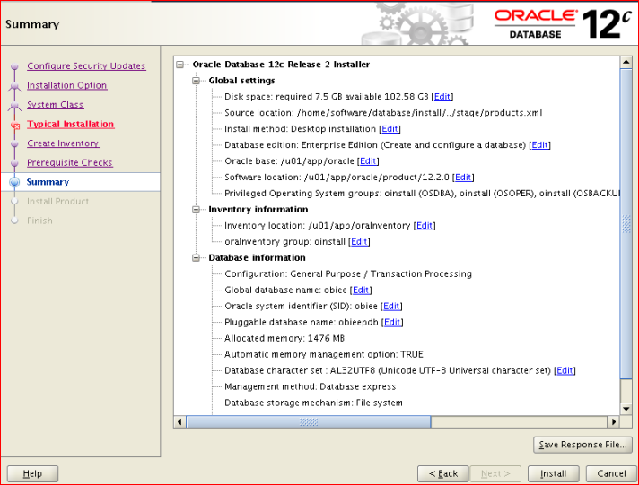

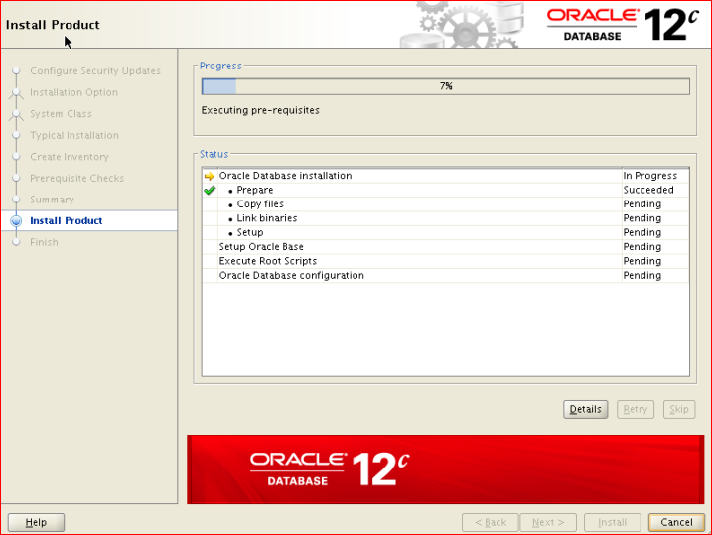

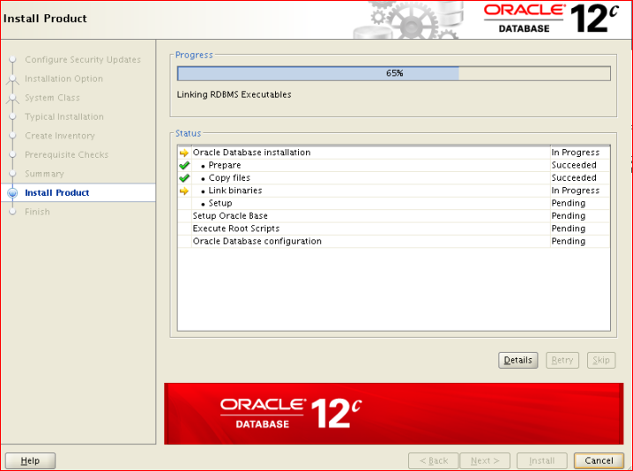

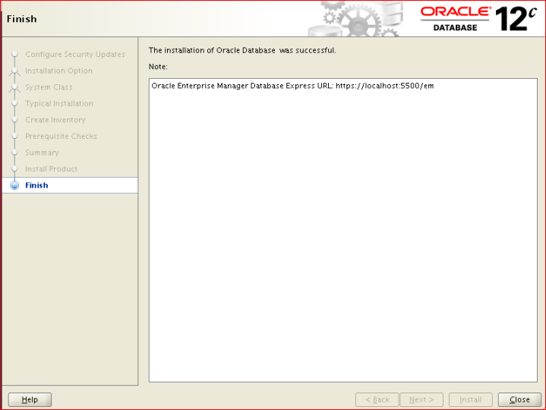

**Installation of OBIEE:**

Download java rpm , WebLogic and OBIEE softwares.

**Java Installation**

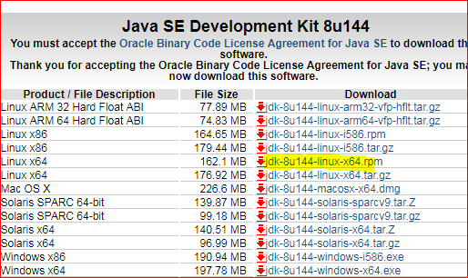

Run the below command,

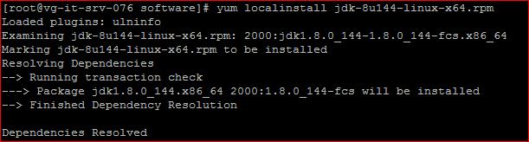

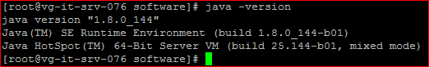

**Installation of WebLogic 12.2.1.0.0**

Run the below command,

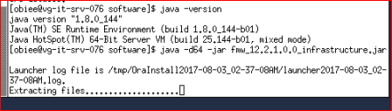

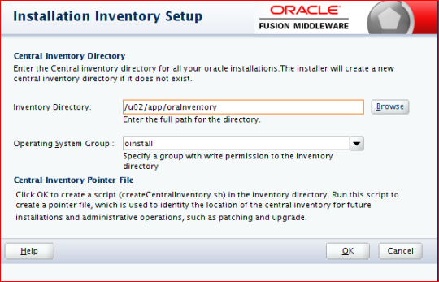

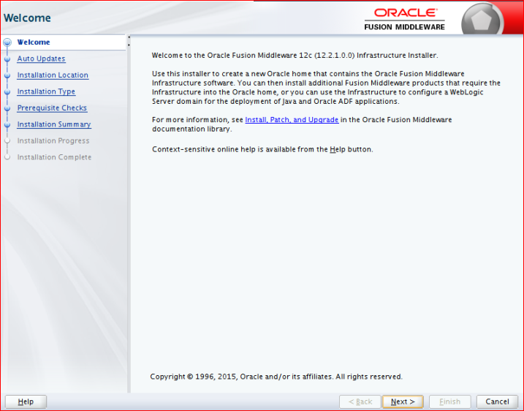

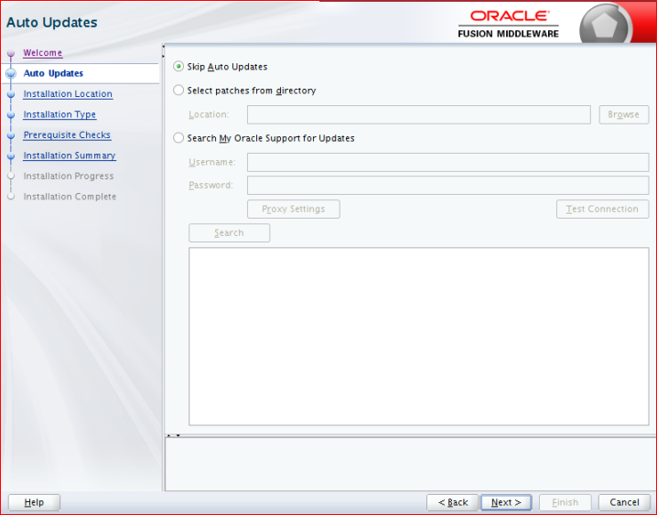

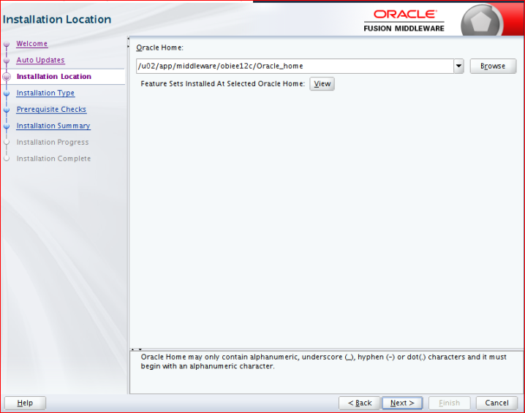

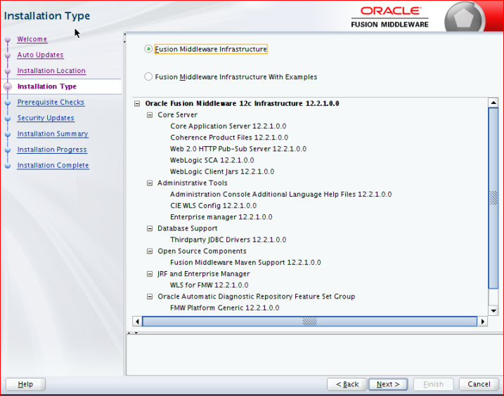

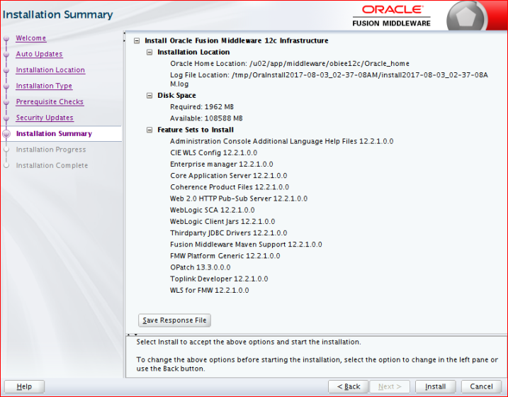

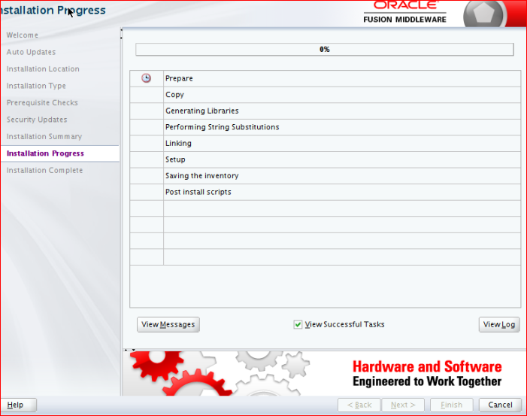

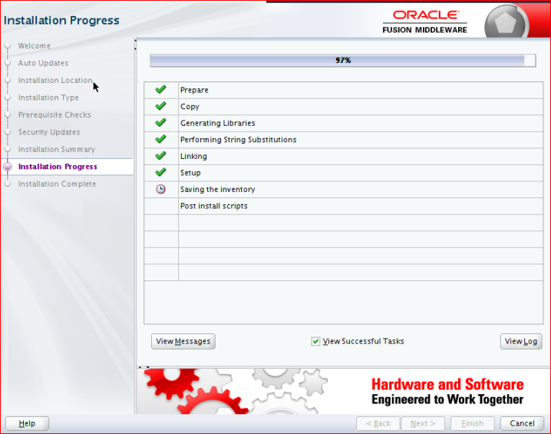

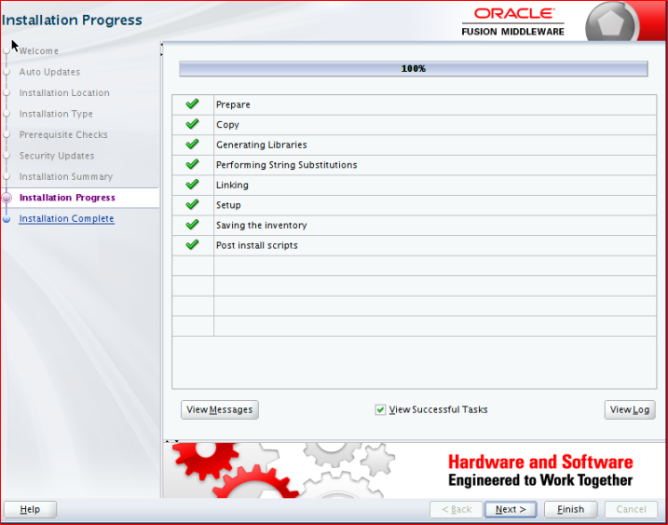

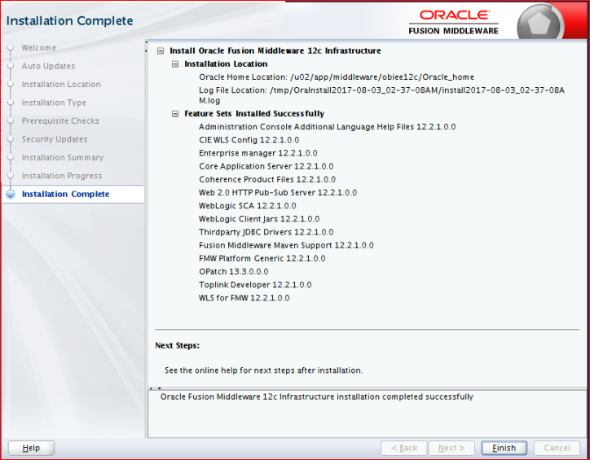

**OBIEE Installation:**

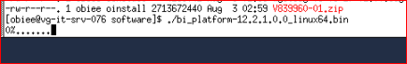

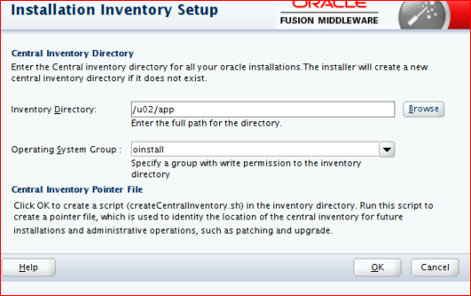

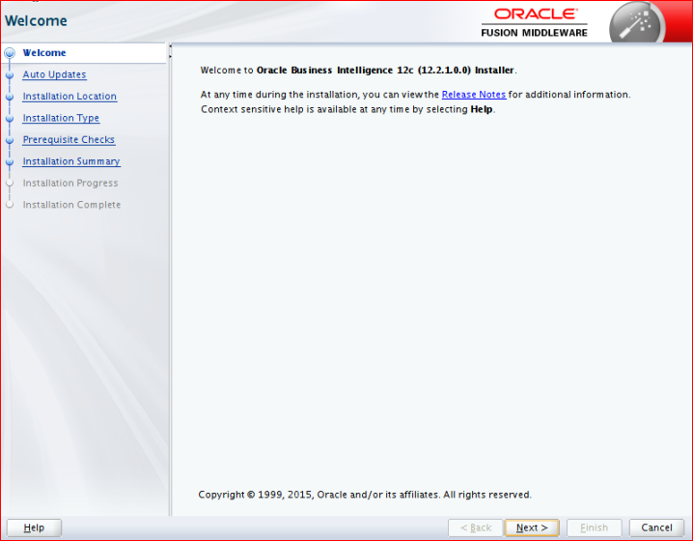

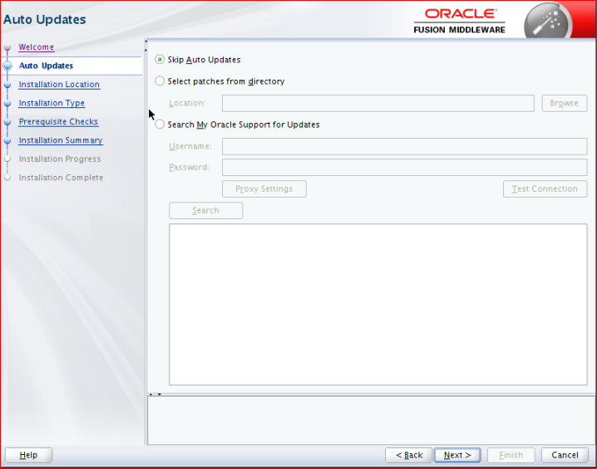

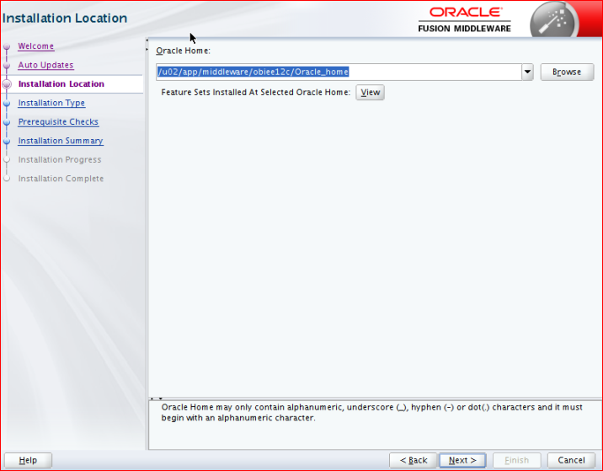

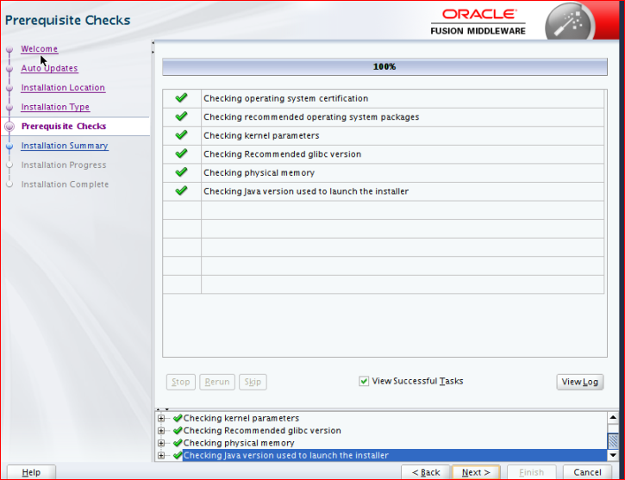

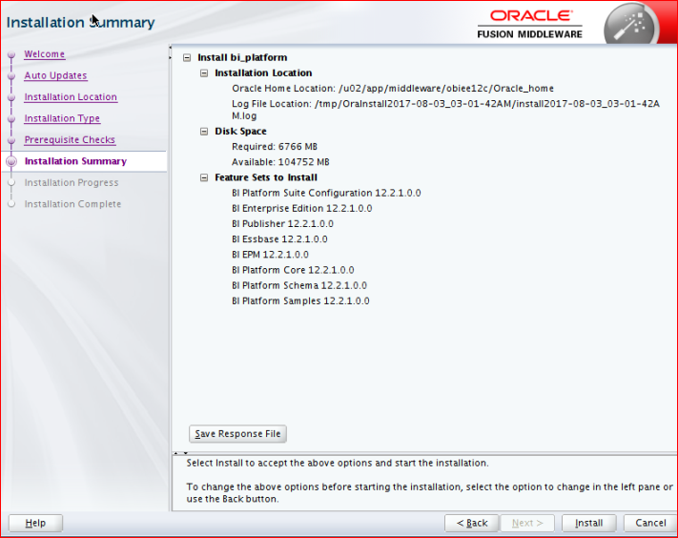

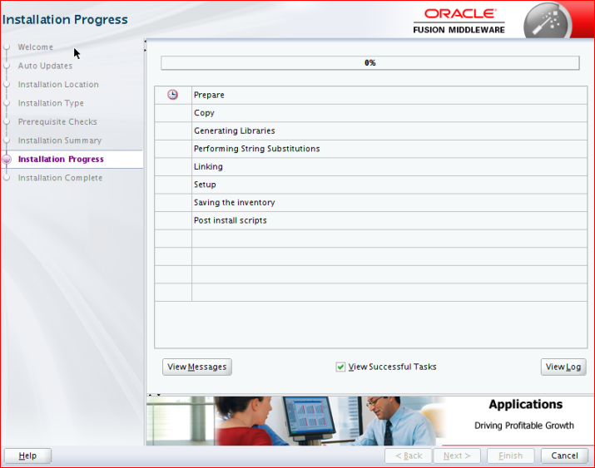

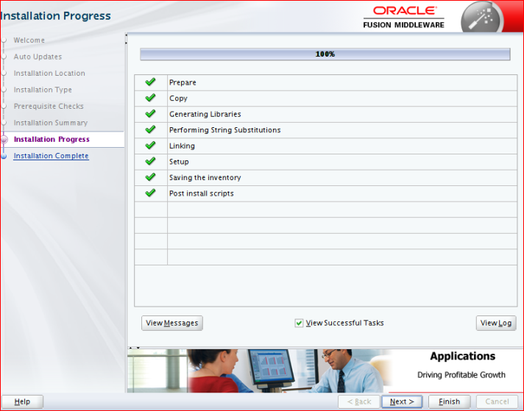

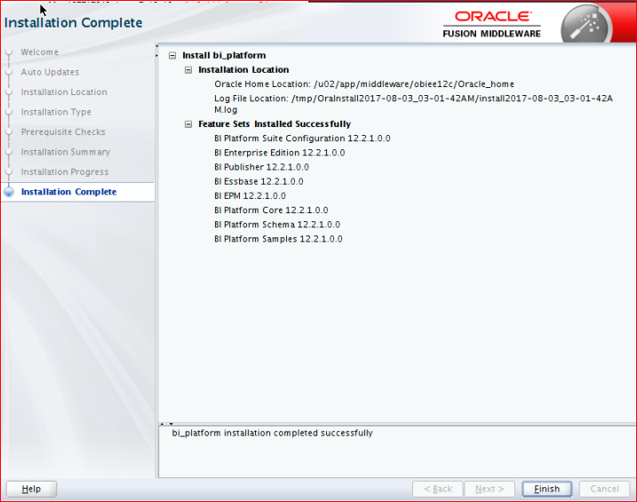

**Repository Creation Utility:**

Run config.sh under oracle_home/common/bin

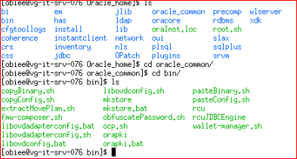

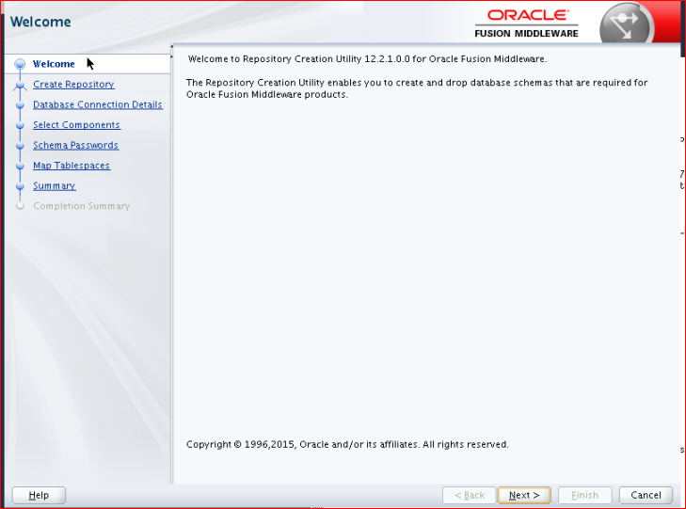

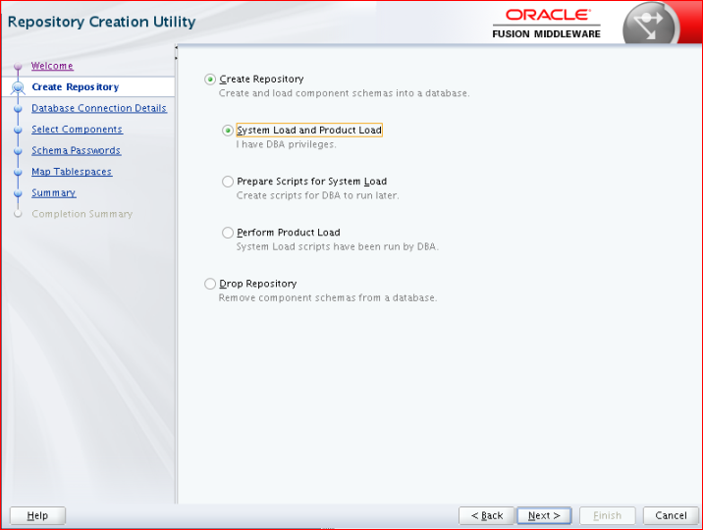

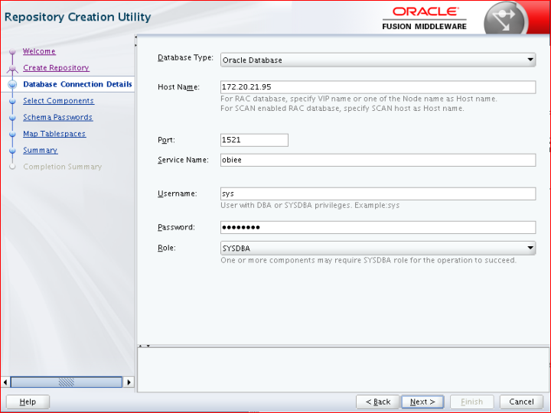

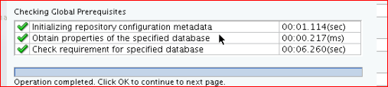

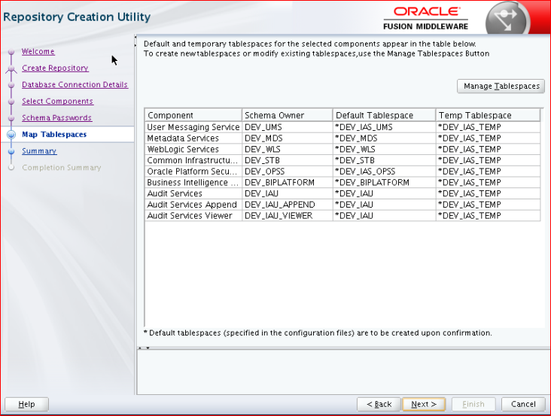

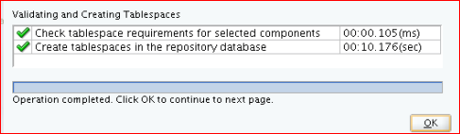

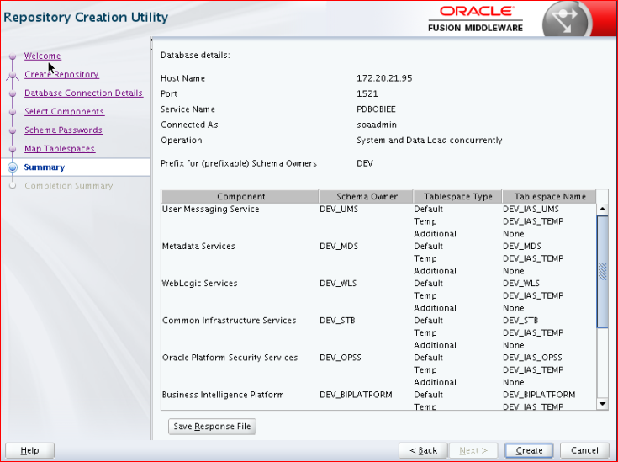

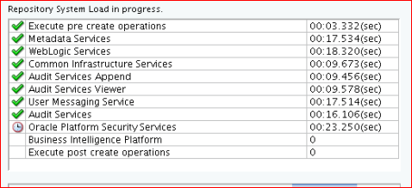

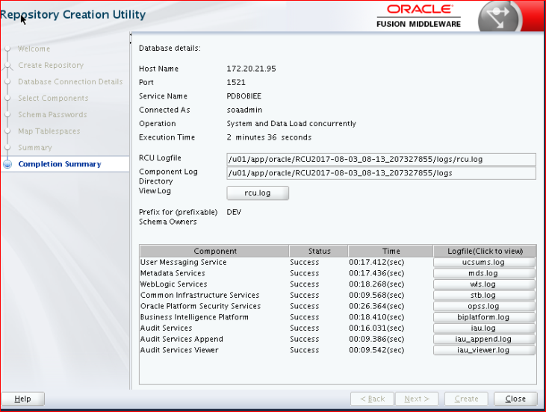

**Domain Creation:**

Run config.sh under Oracle_home/bi/bin

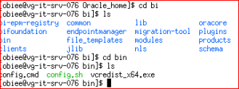

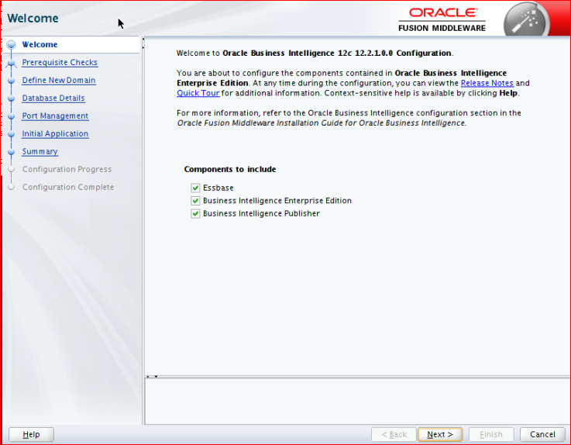

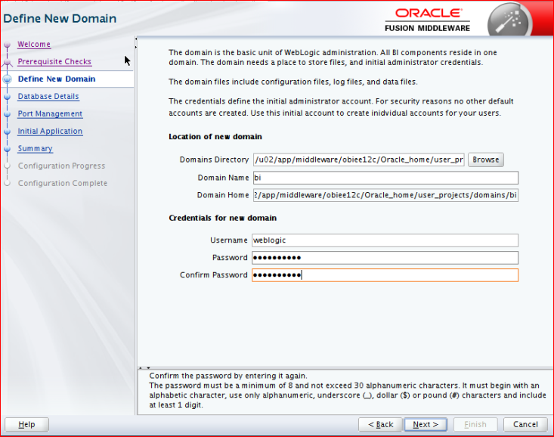

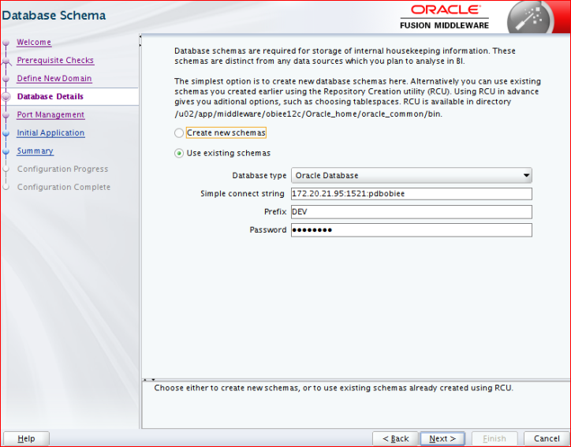

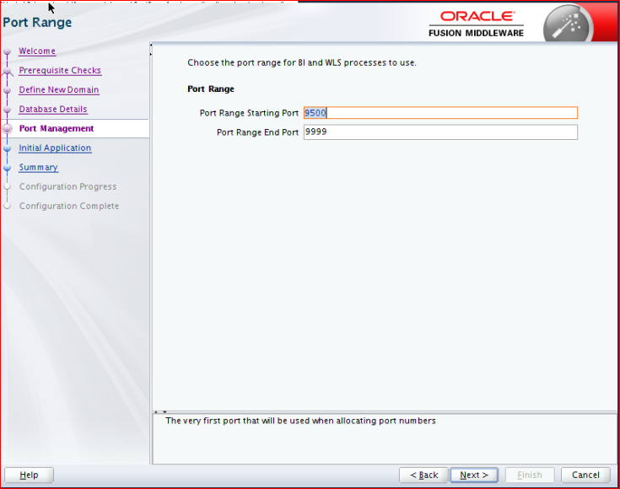

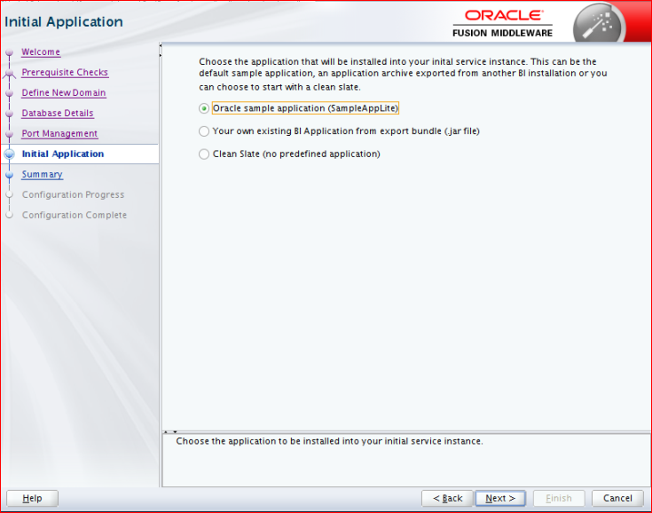

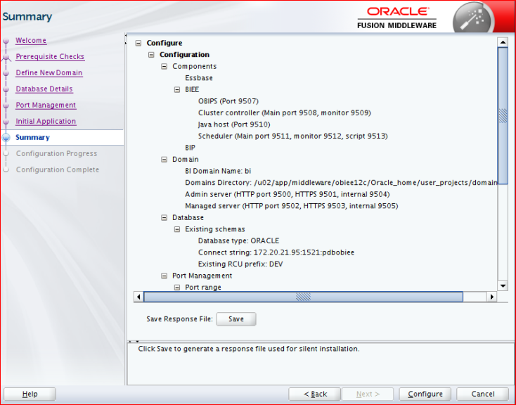

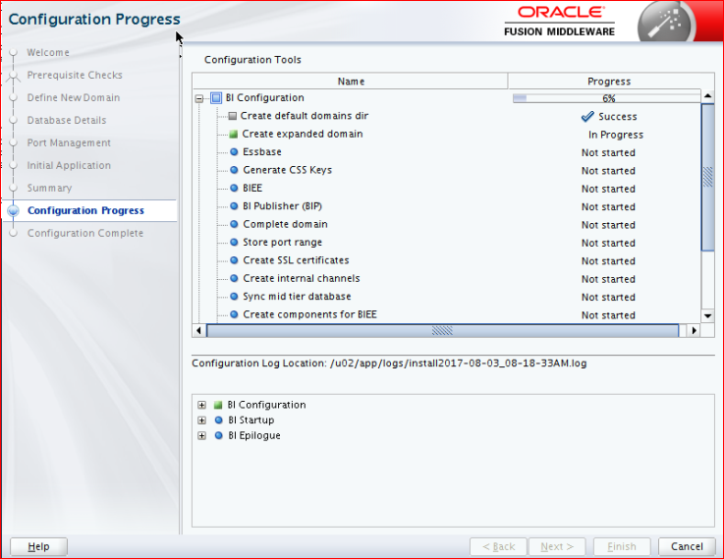

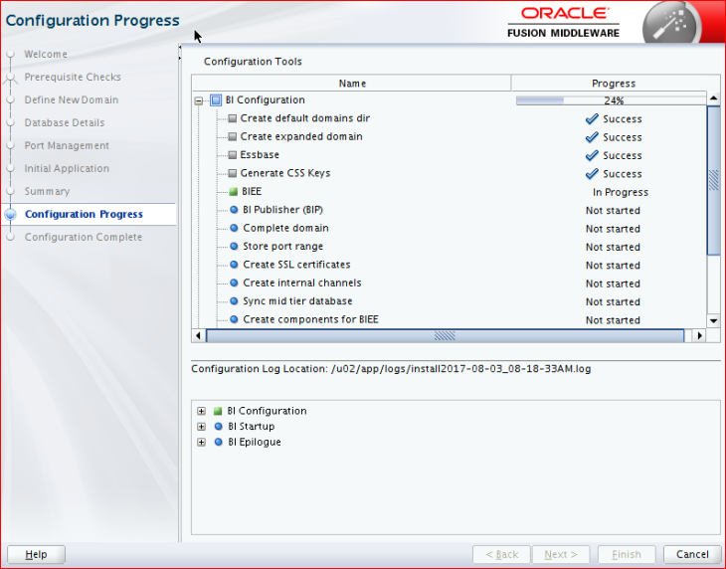

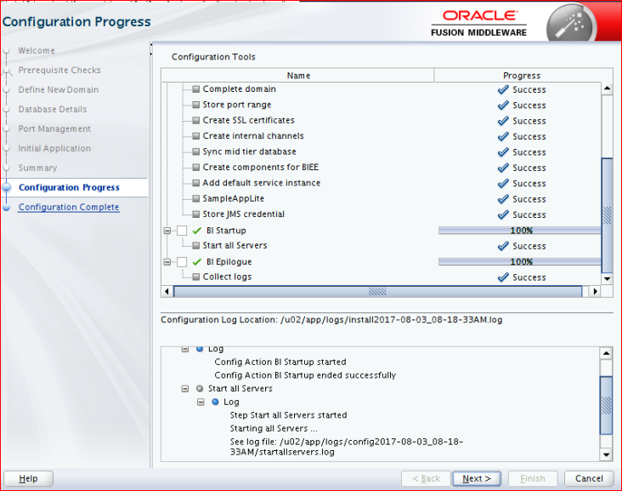

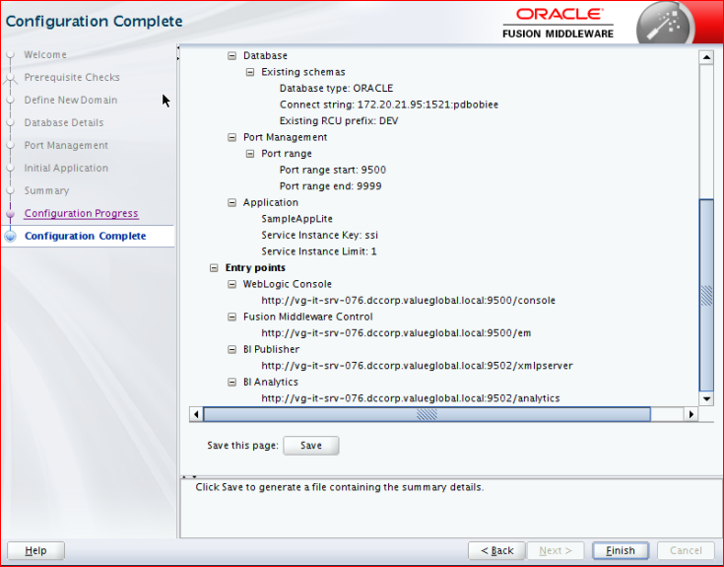

After completion of Installation please check the URLs below.

URLs:

WebLogic Console

<http://vg-it-srv-076.dccorp.valueglobal.local:9500/console>

        Fusion Middleware Control

<http://vg-it-srv-076.dccorp.valueglobal.local:9500/em>

        BI Publisher

<http://vg-it-srv-076.dccorp.valueglobal.local:9502/xmlpserver>

        BI Analytics

<http://vg-it-srv-076.dccorp.valueglobal.local:9502/analytics>